learning_rate=0.00025

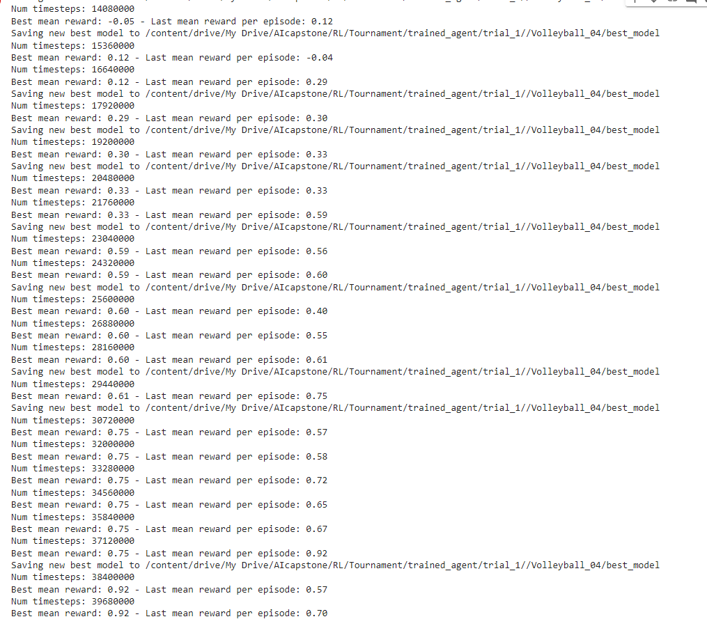

learning_rate: lin(0.0007)

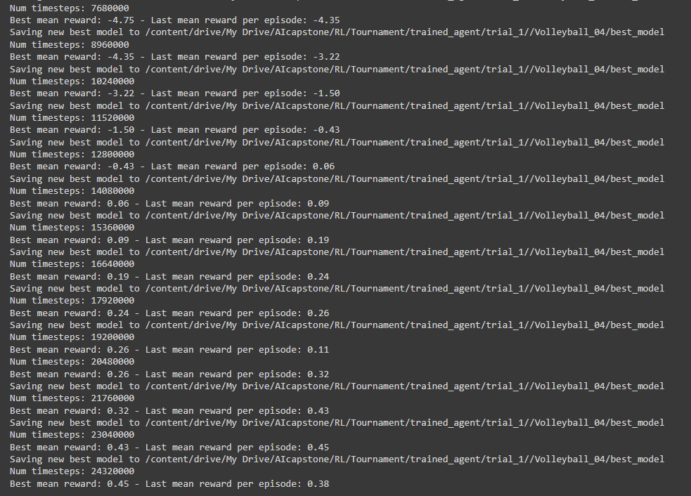

learning_rate: 0.0003

learning_rate: 0.0007